The figure below shows the state diagram of a finite automaton M1. Give the formal description of this automaton. (5 Marks)   
**Provide a conclusion on the language accepted by this machine**

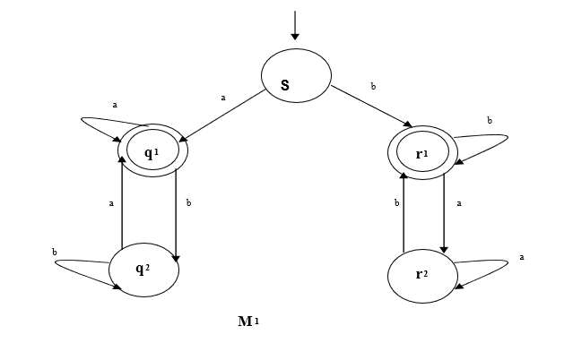

|  |  |  |
| --- | --- | --- |
|  | Input Alphabet | |
| States | a | b |
| S | q1 | r1 |
| q1 | q1 | q2 |
| q2 | q1 | q2 |
| r1 | r2 | r1 |
| r2 | r2 | r1 |

Q = {S, q1, q2, r1, r2}

∑= {a, b}

δ = Transition Symbol

q0= {S}

F = {q1, r1}

|  |  |
| --- | --- |
| Possible path | Pattern |
| S--*b*-->r1 | *b* |
| S--*b*-->r1--*b*-->r1 | *bb* |
| S--*b*-->r1--*a*-->r2--*b*-->r1 | *bab* |
| S--*b*-->r1--*a*-->r2--*a*-->r2--*b*-->r1 | *baab* |
| S--*b*-->r1 --*b*-->r1 --*a*-->r2--*b*-->r1 | *bbab* |
| S--*b*-->r1 --*b*-->r1 --*a*-->r2--*a*-->r2--*b*-->r1 | *bbaab* |
| S--*a*-->q1 | *a* |
| S--*a*-->q1--*b*-->q2--*a*-->q1 | *aba* |
| S--*a*-->q1--*a*-->q1 | *aa* |
| S--*a*-->q1--*a*-->q1--*b*-->q2 --*a*-->q1 | *aaba* |
| S--*a*-->q1--*a*-->q1--*b*-->q2--*b*-->q2 --*a*-->q1 | *aabba* |

**Conclusion**

The machine accepts a language that either starts with an “a” and ends with an “a” or a language that starts with a “b” and ends with a “b”.

**L(M1) = ∑ W ∈ W** , **W** starts and ends with the same symbol.

**Question Seven (from Logic & Truth Tables Lesson):**

The formal description of a DFA is ({q1, q2, q3, q4, q5}, (u, d),δ q3, {q3}), where δ is given by the following transition table. Give the state diagram of this machine. (8 Marks).

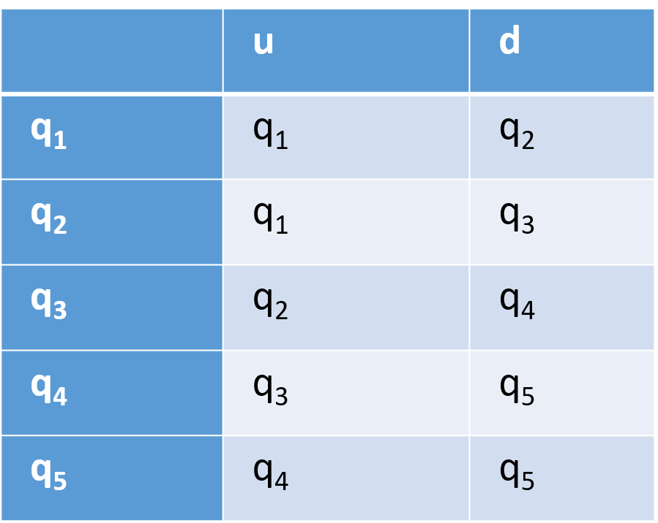

**State diagram of this machine**

q1

q2

q3

q4

q5

u

d

d

d

d

d

u

u

u

u

|  |  |
| --- | --- |
| Possible path | Pattern |
| q3--*u*--> q0--*u*--> q1--*u*--> q1--*d*--> q2--*d*--> q3 | *uuudd* |
| q3--*u*--> q0--*u*--> q1--*d*--> q2--*d*--> q3 | *uudd* |
| q3--*d*--> q4--*d*--> q5--*d*--> q5--*u*--> q4--*u*--> q3 | *ddduu* |
| q3--*d*--> q4--*d*--> q5--*u*--> q4--*u*--> q3 | *dduu* |

**Conclusion**

The machine accepts a language that starts with double ‘u’ and ends with double ‘d’ or starts with double ‘d’ and ends with double ‘u’.